TROUBLESHOOTING TOOLS
Tasks
1. Open the command prompt and use the ipconfig tool to find your computer's IPv4 address and default gateway, then take a screenshot of the output.
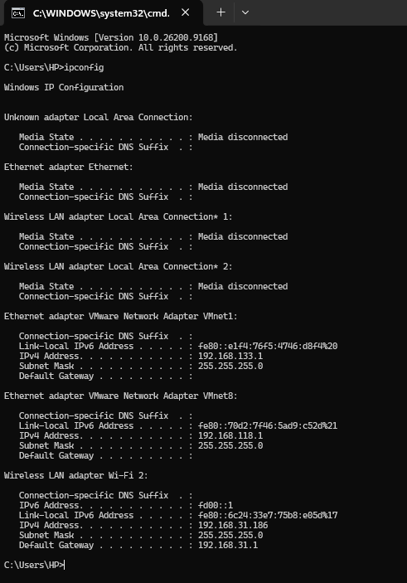

Network Configuration Details
- IPv4 Address: 192.168.31.186
- Default Gateway: 192.168.31.1
- Subnet Mask: 255.255.255.0
2. Use the ping command to check the connectivity between your computer and www.google.com, then note down the average response time shown.
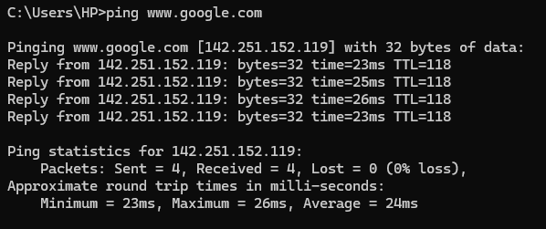

Ping Statistics & Response Time
- Target IP Address: 142.251.152.119
- Packets Status: Sent = 4, Received = 4, Lost = 0 (0% loss)
- Minimum Response Time: 23ms
- Maximum Response Time: 26ms
- Average Response Time: 24ms
3. Run the tracert (or traceroute on Linux/Mac) command to www.flipkart.com and list the number of hops it takes to reach the destination.
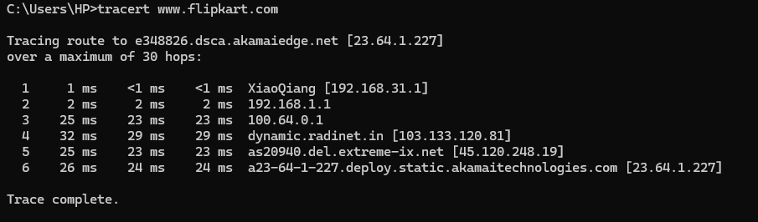

Traceroute Results
- Target Domain / IP: e348826.dsca.akamaiedge.net [23.64.1.227]
- Total Number of Hops: 6 hops
- Hop Breakdown:
  - 192.168.31.1 (XiaoQiang local gateway)
  - 192.168.1.1 (Secondary router / ISP gateway hop)
  - 100.64.0.1 (Carrier-grade NAT / ISP private network)
  - 103.133.120.81 (dynamic.radinet.in)
  - 45.120.248.19 (as20940.del.extreme-ix.net)
  - 23.64.1.227 (Akamai CDN / Flipkart edge server)
4. Use the nslookup tool to find the IP address of www.spotify.com and explain in one line what this tool helps you verify.
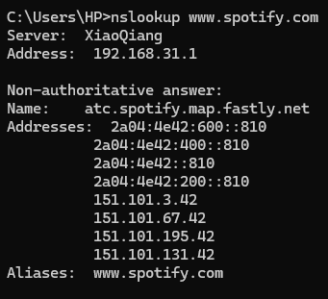

nslookup Results for [www.spotify.com](https://www.spotify.com)
- DNS Server Used: XiaoQiang (192.168.31.1)
- Canonical Name / CDN Mapping: atc.spotify.map.fastly.net
- Resolved IPv4/IPv6 Addresses:
  - IPv6: 2a04:4e42:600::810, 2a04:4e42:400::810, 2a04:4e42::810, 2a04:4e42:200::810
  - IPv4: 151.101.3.42, 151.101.67.42, 151.101.195.42, 151.101.131.42
- Alias: [www.spotify.com](https://www.spotify.com)

5. A friend says they cannot access Zomato’s website from their laptop. Suggest a sequence of three troubleshooting commands (choose from: ping, ipconfig, tracert, nslookup) you would run to diagnose the issue, and briefly state what each command would help you check. Think about checking both network connectivity and DNS resolution.

3-Step Troubleshooting Command Sequence for Zomato Access Issue
To diagnose why your friend cannot access Zomato's website from their laptop (checking both network connectivity and DNS resolution), run the following three commands in sequence:
- ipconfig
  - What it checks: Verifies that the laptop has a valid local IP address and is successfully connected to the local network or Wi-Fi router.
- nslookup [www.zomato.com](https://www.zomato.com)
  - What it checks: Verifies DNS resolution, ensuring that the domain name ([www.zomato.com](https://www.zomato.com)) is correctly translating into a valid server IP address.
- ping [www.zomato.com](https://www.zomato.com) (or tracert [www.zomato.com](https://www.zomato.com))
  - What it checks: Checks end-to-end network connectivity and response time between the laptop and Zomato's servers to confirm if packets can successfully reach the destination.

